|  |
| --- |
| Republic polytechnic |
| M333: Marketing Communications Campaign Proposal |
| **For Ministry of Manpower** |
|  |
| **Team members (Alphabetical Order):**  **CHIN YING QI**  **KHOO JING YU**  **NUR NAZIHA BTE HAIRUDIN**  **NUR SHAFIQA BTE HAJI YUSOF**  **YU WAN LING YVONNE** |
| **05-Mar-14** |

|  |
| --- |
| All rights reserved © 2013 Republic Polytechnic |

Table of Contents

Executive Summary 2

1.0 Introduction 3

2.0 Situational analysis 3

Problems/Issues Identified: 4

3.0 Communication Objectives 4

4.0 Target Audience/Stakeholder Analysis 5

List of questions that we have asked TA: 5

Observations: 5

5.0 Communication Strategy & Key Messages 6

6.0 Communication Tactics: IMC Toolkit 7

(I) Social Media Campaign – Facebook 7

(II) Social Media Campaign – YouTube 10

(III) Other Tools 12

(IV) Roadshow – Games Ideas 15

7.0 Budget 19

8.0 Timeline 21

9.0 Evaluation 21

Appendix 22

# Executive Summary

This is a class project done by five students from the Diploma in Communication and Information Design in Republic Polytechnic.

The proposed integrated marketing communication (IMC) plan is designed to help Ministry of Manpower (MOM) increase the awareness of their message and their visitors’ rates for the yearly public road shows.

The theme of the IMC plan focuses on attracting a new group of foreign workers with the use of new and creative schemes so that they will be informed of the rules and regulations that they would have to abide by when working in Singapore.

From our understanding, we know that the foreign workers find MOM to be intimidating and may not be open to whatever they promote, however, they are more welcoming of ‘Ming’, MOM’s mascot for the roadshows. Therefore, the whole campaign will include the use of Ming the Mascot.

The communications tools employed for the IMC plan will include advertising via posters, SMS blasts, social media campaigns on Facebook and YouTube. Efforts to attract the target audience will continue at the roadshow by having performances, goodie bags, game booths

The success of the campaign will be evaluated by how many people registered at the registration booth, amount of friends that Ming has and a survey done by the target audience on how much they understand the key messages being taught during the roadshow.

# 1.0 Introduction

The Ministry of Manpower (MOM) is a ministry of the Government of Singapore which is responsible for the formulation and implementation of labour policies related to the workforce in Singapore.

To educate the foreign workers about their rules and rights while working in Singapore, MOM organizes public and dormitory road shows at locations easily accessible to them for maximum outreach.

In addition, MOM has provided the foreign workers with an education gallery upon arrival in Singapore to ensure that they have an idea of what is right and wrong while working in Singapore.

# 2.0 Situational analysis

|  |  |
| --- | --- |
| **Strengths** | **Weaknesses** |
| * Held past events before (focus on the areas that are successful) * They managed to reach out to a good amount of people who visited the previous road shows * They put up posters and have ready-made messages (E.g. REST WELL, WORK WELL etc.) * Created Ming, the mascot for entertainment and branding purposes * Prevent them from being bullied by employers (POLICIES were set) | * Their past efforts do not seem to be working * Used the wrong approach in the past (aggressive and forceful) * SMS and flyers – limited * Ming, not made use of in other collateral 🡪 links to our strategy/recommendations (more could be done) * TA are intimidated by MOM (see MOM being more authoritative) * Miscommunication between MOM and foreign workers (language barrier, understanding – different groups of TA takes in information differently) because of the gap they have in-between each other |
| **Opportunities** | **Threats** |
| * Total foreign workforce accounts for nearly 40% of SG’s total workforce in 2012 * Foreign workers becoming media savvy   🡪 we decide to reach them on a personal level - recommendations  TA able to afford data plans by purchasing prepaid card | * No control on whether TA will want to spend their weekends at the road show * Due to the recent riot cases, the general public might discriminate on foreign worker (which might cause more difficulties for MOM to reach TA) * MOM needs to soften image |

## Problems/Issues Identified:

* MOM is seen as an authoritative figure and the foreign workers are hesitant to approach MOM for help. The recent riots may have further intensified the fear and reluctance of foreign workers to approach MOM.
* MOM created the mascot Ming to soften their image, but based on our understanding, Ming only appeared during the MOM Public Road shows.
* MOM employed only traditional media platforms to reach out to the foreign workers.
* MOM is unable to find out if the workers really understand and internalise the important key information that MOM wants the foreign workers to know, understand and practise.

# 3.0 Communication Objectives

In view of the situational analysis, we will focus our communications campaign to achieve the following objectives:

1. To increase awareness of the MOM Public Road shows among the target audience through new media platforms;
2. To brand MOM as a partner for the foreign workers; and
3. To strengthen the understanding of the key information on employment regulations, rights & responsibilities as well as the welfare messages among the target audience during the MOM Public Road shows.

# 4.0 Target Audience/Stakeholder Analysis

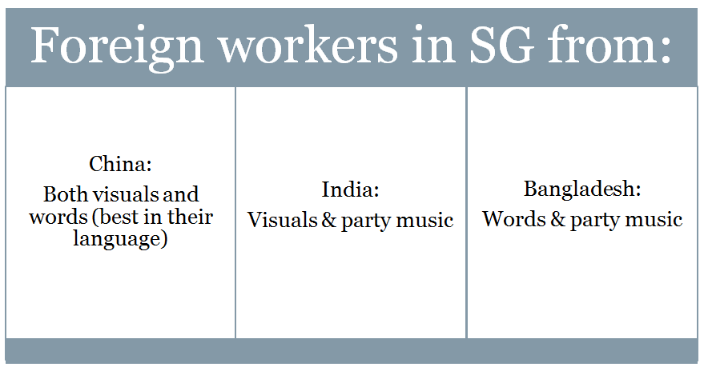

We interviewed some foreign workers on 20 January 2014 at the construction site near Jurong East MRT Station and found out that they understand simple English.

## List of questions that we have asked TA:

1. Do you know about the road shows?
2. If yes, from who/what?
3. How was it? (the experience) What do you like about it?
4. If no work, where will you be on weekends and what do you do?
5. Do you have a smart phone?
6. What are the things that you always do on your phone?

**Here are the common responses we collected**:

* “I like free, free I like.” Raj Kumar, Indian, 22 - We understand from this statement that they enjoy getting free goodies.
* “My friends drink and dance with me, I very happy.” Aakaar Malik, 27 - From this, we know that the workers like to party during their rest time.
* “I go Mustafa every Sunday.” Omar, Bangladeshi, 28 - Some other places that they frequent are Chinatown, Lucky Plaza, and Little India.

## Observations:

1. They mainly use social media for video viewing, contact their family and friends and listening to music.
2. They use YouTube for videos and Facebook for contacting family and friends.

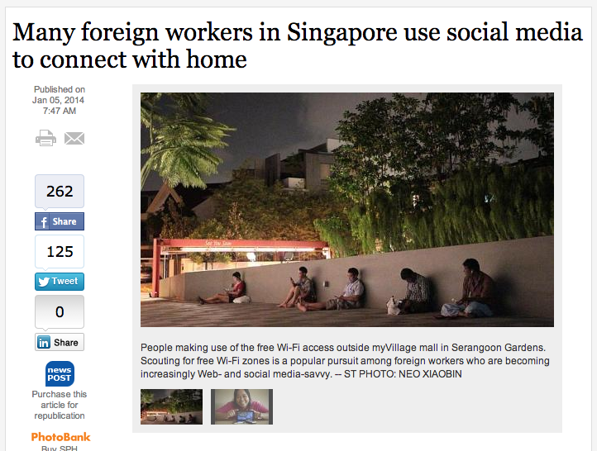

[Source](http://www.straitstimes.com/breaking-news/singapore/story/many-foreign-workers-use-social-media-connect-home-20140105): This article is from Straits Times Online which highlights the current increasing trend of foreign workers use social media such as Facebook

# 5.0 Communication Strategy & Key Messages

From our understanding during the briefing conducted by M.O.M as well as our situational and audience analysis, many foreign workers are afraid and sceptical of MOM personnel. They are apprehensive about approaching M.O.M for help. As such, they may not be open and receptive of information pass down to them through such “official” channels.

M.O.M created their mascot Ming in an attempt to soften their image and make them seems more approachable. However, Ming only appeared during the M.O.M Public Road Shows and not in any of the other marketing communications campaigns/efforts. This strategy has been used successfully by other government agencies such as Water Wally by the Public Utilities Board (PUB) and Captain Green by the Ministry of Environment. With the use of these mascots, PUB and Ministry of Environment have created brand identities for their campaigns which have made it easier for people to associate the mascots with the agencies.

Ming will be used as the main ambassador for this campaign. This will add more visibility to Ming and for the foreign workers to easily associate Ming with M.O.M, without having to mention the latter. Ming will anchor the campaign which will largely be communicated through new media platforms such as Facebook and YouTube.

Thus our proposed key message will build around “Ask Ming”.

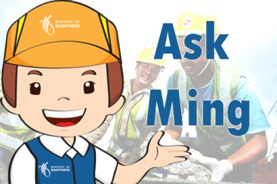

# 6.0 Communication Tactics: IMC Toolkit

## Social Media Campaign – Facebook

According to the interviews we have conducted with the foreign workers, we have found out that most of the foreign workers in Singapore do use social media tools such as Facebook as a way for them to keep in touch with their loved ones back home. Considering they spend their time on Facebook, we proposed that MOM make use of this platform to reach out to the foreign workers.

In order to help bridge the relations between the foreign workers and MOM, we would make use of Ming as the face to help MOM answer questions.

This Facebook account will be attached to MOM’s current Facebook page and the target audience will be able to ‘like’ it as well as recommend their fellow foreign worker friends to like it as well, which will spread MOM’s message.

Ming’s page could also make use of announcing any upcoming events by MOM that would require Ming to be a part of. An example being for road shows.

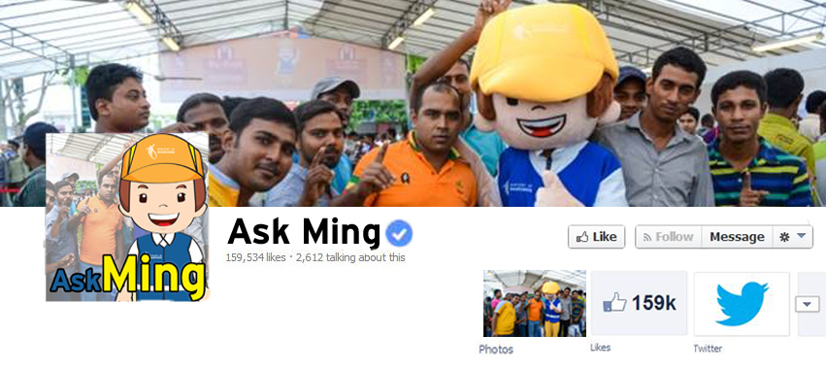

**Fig 1: Example of ‘Ask Ming’ Facebook page**

**How do we encourage people to ‘LIKE’ Ming on Facebook?**

1. **Contests** 
   1. **GUESS THE PHOTO**
      1. What is it about?

‘GUESS THE PHOTO’ is a simple game where Ming will post a distorted/blurred out image pertaining to one of the messages of the M.O.M campaign.

* + 1. How will people be involved?

Users will be able to participate by simply putting their answers in the comments section. The first 10 correct answers will be given a shout out by Ming and his picture will appear on Ming’s timeline as ‘Ming’s Friend(s) of the Week’

Additional content: After revealing the correct answer and winner, Ming will inform the people the message behind the picture (E.g. Picture of a construction helmet 🡪 Safety first).

* 1. **TAKE A PHOTO WITH MING**
     1. What is it about?

This is a contest made specially for the road show. Since the TA are known to love taking their photos taken, this idea is taking the oppurtunity of their likes.

* + 1. How will people be involved?

People taking part will have to be at the road show, spot Ming and request to take a picture with him. Once the picture is taken, Ming will give them a special prize. The person on duty with Ming will upload the picture on his Facebook Page and will tag the participant.

* 1. **PRIZE TO BE COLLECTED AT ROADSHOW**
     1. What is it about?

To collect the prizes, winners will be notified via e-mail. The competitions held on facebook will lead up to the roadshow and in order to collect their prizes, they must go to the roadshow registration booth and present their e-mail address.

* + 1. How will people be involved?

With prizes involved, it will be an incentive for the foreign workers to participate and come to the event. With prior knowledge that they enjoy receiving free gifts and prizes, they might also ask their friends along to the event.

**How will this benefit M.O.M?**

This will strengthen the relationship of M.O.M and TA together through the interaction with Ming.

1. **Publicize on promotional tools**

Since the key message revolves around Ming, it would only make sense that to publicize his Facebook page on every promotional tool that we would have in order to instill in the minds of the FWs and FDWs about its existence. The target audience would have to go to Facebook and ‘Like’ Ming. This helps to create a connection and interaction between M.O.M and the TA.

These will appear on campaign posters, flyers promoting the road show and also in several items that will be given during the road show itself.

**Facebook advertising on the roadshow**

M.O.M could also make sure of Facebook advertising via ‘suggested pages’ to reach out to the TA. ‘Suggested pages’ would be more effective than the advertising corner at Facebook as the TA would be able to view it on both their computer and mobile phones.

An example of an advertisement to make use of promoting the MOM Public Road shows, which can be seen in the picture below.

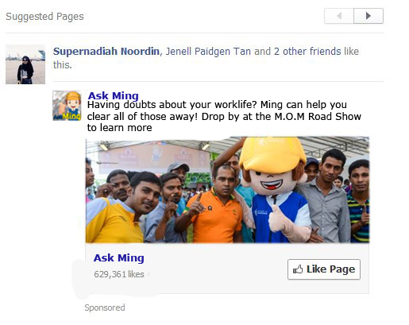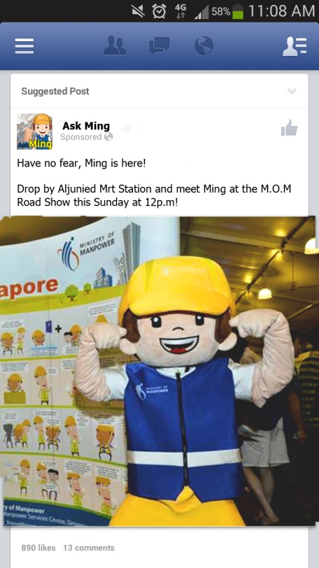

**Mobile Version**

**Web Version**

## Social Media Campaign – YouTube

After researching the MOM YouTube page, we decided to come up with an idea of a video to further engage our target audience and educate them about our message. As mentioned previously, we would want to make full use of Ming the mascot and thus creating a whole new video with him as the star.

**Idea #1: Paper Stop Motion Video**

In order to make the video as engaging as possible, we have decided to use a paper stop motion format. The video will also be in a form of a narration while a human hand will move the characters of the video around.

Videos with the format of stop motion have a higher chance being viewed by people due to its interesting concept. An example would be the video featured below. The video has received over 40,000 views.

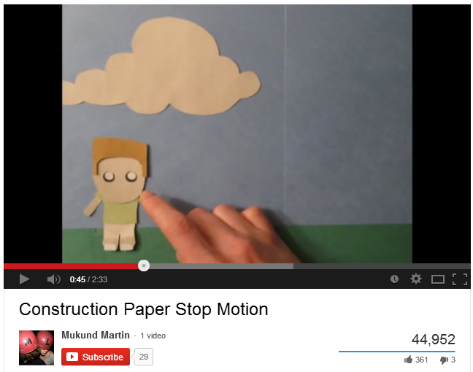  
Video source: <http://www.youtube.com/watch?v=KaaOuqgAsBg&hl=en-GB&gl=SG>

The picture below shows the important characters (Characters may be changed depending on storyline, but Ming must be present):

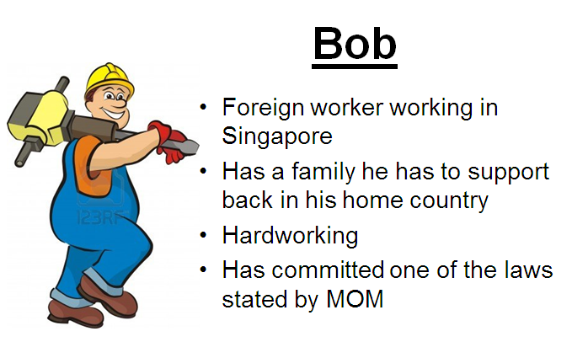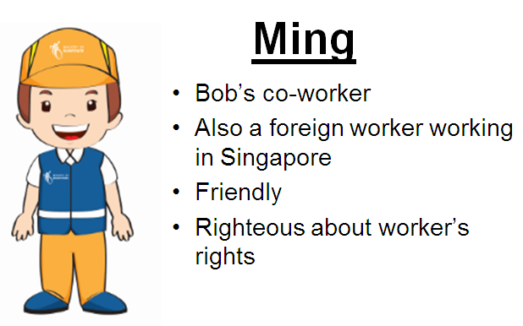

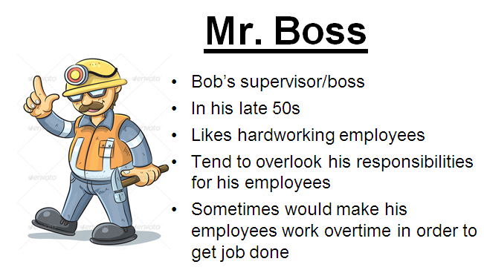

An example of the storyline:

***Main character, Bob has been working overtime and his boss notices but takes advantage of it. Bob tells Ming that he is not paid overtime so Ming tells him that he has to stand up for his right and also remind him of the conditions of working overtime.***

The storyline will be interchangeable even when there is a new message or rule MOM wants to bring up. The video will be shown on MOM’s official YouTube page and it will be linked to its social media site such as Facebook in order to bring more attention to it.

During the time period of promoting the road show, the ending will announce when and where it will be held if they want to learn more about their rules and rights.

## Other Tools

1. **Posters**

In order to spread the word about Ming, he needs to be present in every marketing communications collateral. First would be the posters. This would mean revamping of all existing posters and other marketing communications tools as well.

Each poster will insert different key information, similar to the previous ones. Each poster would have friendly and welcoming reminders while encouraging people that they could feel free to ask MOM anything. However, instead of using the term ‘ask the MOM anything!’ we would use ‘Ask Ming anything!” or “Do not fear, Ming is here”.

There will be different versions of the poster that will have the same content as the previous ones but with different messages with 3 different languages (English, Tamil and Chinese):

* Ming says “.........”
* Ask Ming anything!
* Do not fear, Ming is here!
* Don’t forget your R&R, Rules and Rights!
* Work hard, stay happy

We will also insert a blurb about the next MOM Public Roadshow with details.

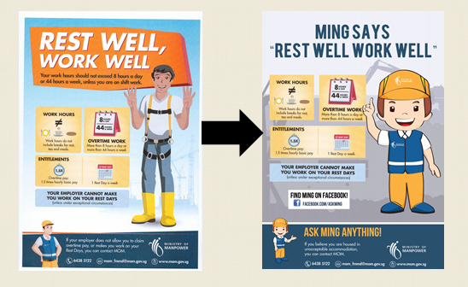

The chart above shows the old and revamped version of Ming in the poster. Other details of the campaign are kept the same.

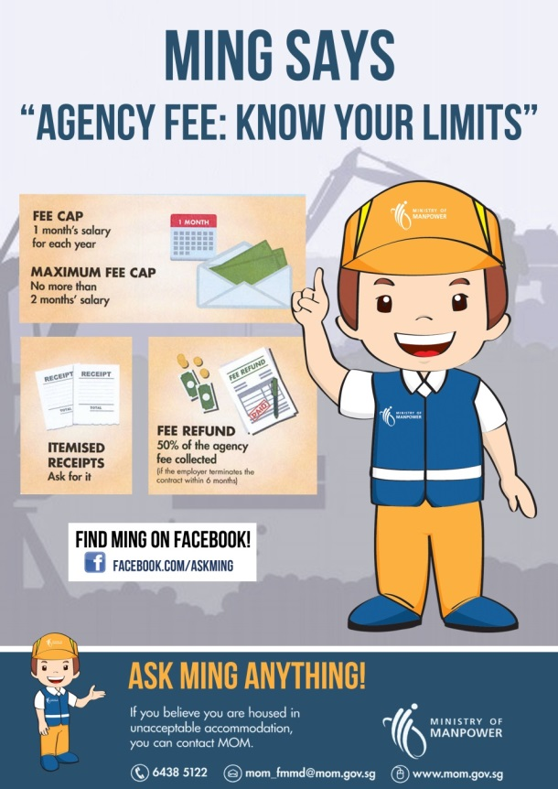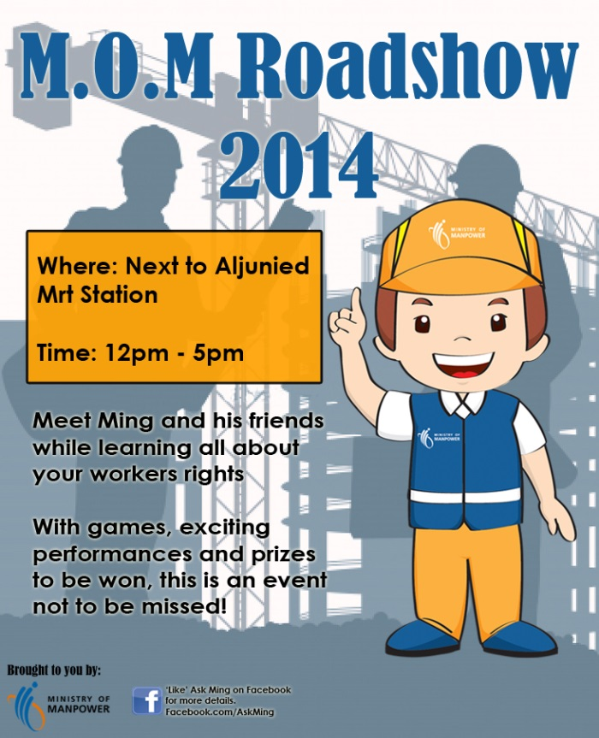

1. **Direct marketing - SMS Blast**

While conducting the survey with the foreign workers, we have found out that each of them are very close with their phones and checks their messages everyday.

With this information we gathered, we have decided that we would make use of SMS blast to inform people of the roadshow in a week in advance.

**Example of SMS blast:**

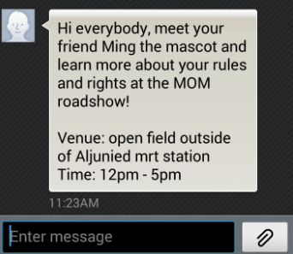

## Roadshow – Games Ideas



In order for the foreign workers to better understand and remember the key information that MOM has been trying to communicate to them, we are proposing to redesign some of the public roadshow’s activities.

The components of the roadshows are written in the table below:

|  |  |  |
| --- | --- | --- |
|  | **Components of the events** | **Details** |
| 1. | Registration booth | In order to get a rough measure of the turnout, a registration booth will be set up at the front of the event area.  The foreign workers will register here in order to get goodie bags containing bottled water, pamphlets, flyers, key chains etc. the purpose of this booth is to gauge how many visitors turn up and also to attract more foreign workers to come since they like freebies. |
| 2. | Information booth | The information counter will be named “Ask Ming Anything” according to the theme of the event, which is centered around Ming the mascot. The workers manning the booth will be dressed as Ming in order to fit in more with the overall message of asking Ming anything.  At this booth, the foreign workers can ask any queries related to the event or to work and they will be answered by “Ming” in a friendly manner, making the mascot and MOM seem more approachable. |
| 3. | Signboards | Signboards that carry MOM’s 7 key messages to the foreign workers will be placed near the game booths so that they can read and understand what MOM wants them to do while queuing up to play games. These signboards will be very visual and written in simple English for them to understand better. |
| 4. | Ming the Mascot | All those working at the event will be dressed as Ming the Mascot since the event is centered around Ming. The actual Mascot will also be walking around for the visitors to take a photo with him since he is a popular attraction at roadshows |
| 5. | Game booths | There will be a total of 5 game booths at the event   1. **This or That?**   At this booth, players will be given two scenarios. One scenario will depict the wrong thing to do and the other will depict the right thing to do at work. Players will have to think of which scenario is right. When they get two correct, they get a prize.  This game helps them understand what is the right thing to do and it will re-enforce MOM’s key messages to them in a fun manner.   1. **Target Practice**   There will be 7 targets on a board that will have MOM’s key messages on them. Players will then have to choose 3 messages to aim darts at. If they successfully aim their darts at their selected messages, they win.  Workers at the game booths will also explain to them what their key messages mean to ensure learning.     1. **Fix it!**   Players will have to work in teams to assemble a very big puzzle. The completed puzzle will form a picture of Ming the mascot practicing one of MOM’s key messages e.g. work well, rest well. however, before they play, no reference picture will be given to them and they must figure out what the message is at the end.  As they fix the puzzle they will slowly come to realize what the message is and that is how they learn.     1. **Puzzled!**   Players will be given 3 pictures of workers practicing MOM’s key messages. Then, they will have to match each picture to the correct message.  Workers will explain each key message that they got wrong in order to ensure that the foreign workers understand the key messages.   1. **Knock it down!**   At this booth, players will have to knock down the cans that are stacked up. However, to get the balls to knock the cans down, they must successfully name 3 key messages.  This will test their knowledge on what they have learnt during the event. |
| 6. | Performances | While waiting at the game booths, the visitors will get to watch performances by Chinese dance groups, Indian dance groups, singers and magicians. There will also be skits performed by Ming to emphasize the importance of rules and rights among the foreign workers.  This will keep them entertained and educated while waiting. |
| 7. | Goodie bags | The goodie bags will be given out upon registration and will contain the following items:   * Bottled water * Towel * Pen * T-shirt (free size) – Each Tshirt will have different messages * Biscuits * Pamphlet of MOM’s message * Feedback form * Pre-paid card from Singtel/M1/Starhub |

# 7.0 Budget

Total budget given to us is $70, 000.

The table below shows a breakdown of the budget required for our proposed campaign.

|  |  |  |  |
| --- | --- | --- | --- |
| **Tools** | **Description** | **Cost** | **Est. Total cost** |
| Poster | 5 different versions  3 languages  Total number of posters needed: 750 | 50 x 5 versions = 250 pieces  250 x 3 languages = 750 pieces (total)  100 pieces (coloured, glossy) = $1,000  750 pieces (coloured, glossy) = $7,500  *Cost depends on printing material* | $8,000 |
| Video | Basic editing work to be done by RP students (From CEC or STA). | Offer it to them as an industry project (no pay) unless there are excess budget ($50 per student). Max five students needed. | $300 |

The table below shows the budget needed for the roadshow:

|  |  |  |  |
| --- | --- | --- | --- |
| **Tools** | **Description** | **Cost** | **Est. Total cost** |
| Tent | 1 big tent for the whole event | $500 | $500 |
| Bag | 2k of bags | $3 | $6000 |
| Carnival game rental | 3 games stalls will be rented | $288 | $1440 |
| Bottled water | 2k of bottles prepared | $1 | $2500 |
| T-shirts | 2k prepared | $8 | $16000 |
| Biscuits | 2k prepared | $30 x 20 | $600 |
| Pamphlets | 2k printed |  | 2000 |
| Feedback form | 2k printed | $0.20  $0.20 x 2000 = $400 | $450 |
| Pre-paid card | 200 will be ordered | $16  $16 x 200 = $3200 | $3200 |
| Performers | 2 dance groups and 1 magician will be hired | get them to volunteer from the various CCs |  |
| Signboards | 10 | $150 x 10 = $1500 |  |
| Additional costs |  |  | $10,000 |

Total cost: $45,000

# 8.0 Timeline

|  |  |
| --- | --- |
| **Schedule** | **Tools** |
| 1st April - 14th June | YouTube advertisements |
| 15th April - 13th June | Posters |
| 21st April | Launch of ‘Ask Ming’ Facebook account |
| 1st - 31st May | Facebook advertisements |
| 15th May - 7th June | Cinema advertisements |
| 1st - 7th June | Flyers |
| 15th June | MOM Roadshow |

# 9.0 Evaluation

There will be an evaluation conducted after the timeline of the roadshow to measure the success rate of the campaign. Evaluation will be done by counting the number of responses of views, likes and statistics of visitors. A survey will be conducted to find out the perception to gain feedback of what they think

|  |  |
| --- | --- |
| **Evaluation methods** | **Description** |
| Registration booth | See how many people register for event |
| Amount of friend requests from Ming through the Facebook page | It shows the outreach of the campaign |
| Conduct survey | It shows the understanding of the foreign workers on the topic of the key messages |

# Appendix

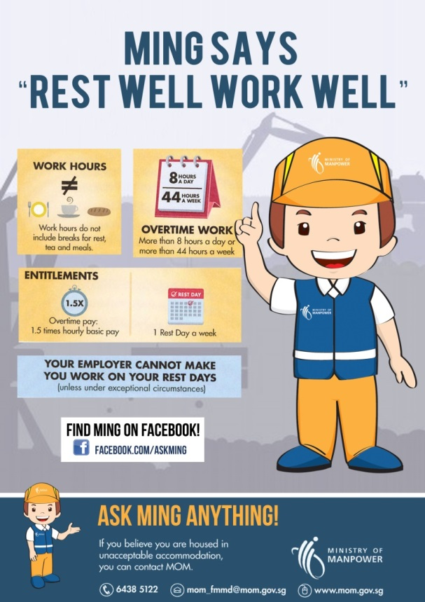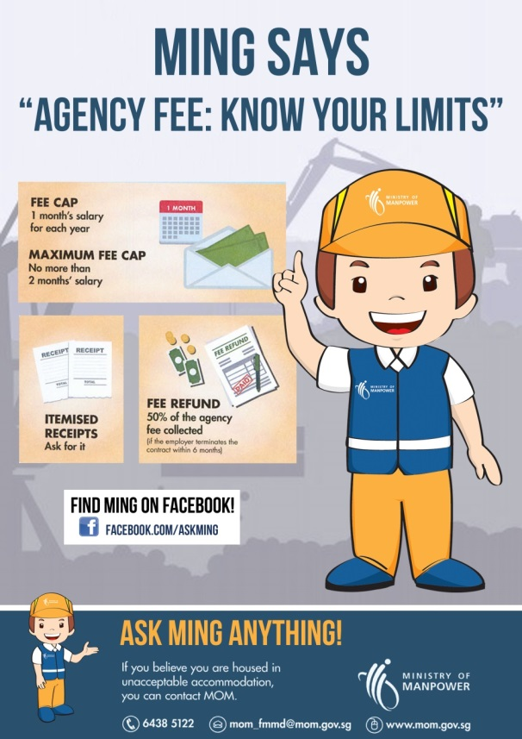

**Both posters above are a sample done by Chin Ying Qi**

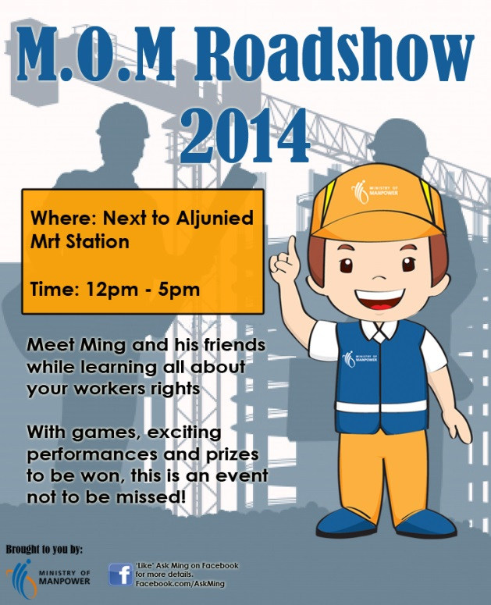

**The flyer for the M.O.M Roadshow 2014 is a sample done by Nur Naziha Bte Hairudin**